**Clustering Results for UK Online Retail dataset**

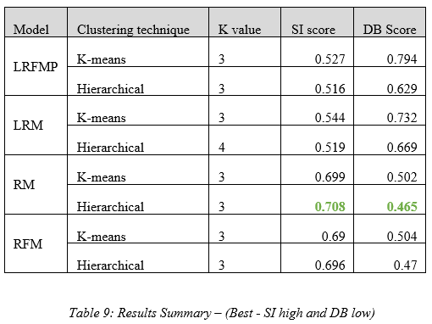

**Clustering Results for H&M Online Retail dataset**

